

IBM Global Services

SDS R3: Views Notation for the Operational Viewpoint

Guideline

© Copyright International Business Machines Corporation 2002, 2012

All Rights Reserved
Version 3.0, July, 2012

Brief Description
This document presents standard notations for those views presented in the artifacts associated with the Operational Viewpoint of Architecture within IBM’s Unified Method Framework (UMF).
Section “About this Document” introduces the scope of this notation, explains why such a notation is needed and who might use it; and how the notation relates to the broader context of UMF.
Section “Operational Viewpoint View Notations” describes the notations for each type of view, organized by artifact.
[Ref 1] provides a detailed definition of all the symbols appearing on these views.

About this Document

Definitions and Conventions used in this Document
This document adopts UMF’s “model – viewpoint – view” approach to modeling (see [Ref 3]), in which:
A Model: Is a collection of descriptions and relationships that document the target IT system’s structure of parts and their behaviours.
A Viewpoint: Is an observational point-of-view looking onto the model - in other words, a definition of the types of parts of interest to the model’s observer – referred to as the stakeholder, together with a definition of how the stakeholder is to render these model views (i.e. the views’ notation).
A View: Is an actual "diagram", "sketch", "table", "matrix", "list", and even "picture" and "narrative" of parts of the model - anything an observer draws/writes/reads as a representation of some part of the model from a viewpoint.
The essence of this approach lies in the distinction between a model, which may be stored in a manner that helps ensure its completeness and integrity whatever viewpoint it is observed from; and individual sets of views of the model which are designed to convey meaning to a specific type of observer, such as diagrams, sketches and lists within a “report”.
Keeping this distinction between “the model” and “views of the model” is a critical success factor in ensuring a target IT System’s design evolves in a cohesive and coherent way, with all model changes (achieved from any viewpoint) are faithfully rendered in all views from all viewpoints.
In UMF, the definition of a model’s standard viewpoint is part of each UMF artifact (which includes other stakeholder concerns such as development guidance and development time estimates), while the “report” presenting the set of views of an actual model from that viewpoint is part of the project’s artifact.
UMF uses the same name for the standard viewpoint and for a project’s view of its target IT system from that viewpoint; for example “Node Model” and “Operational Model”:
- In UMF
- The Node Model artifact description (ART 0524) includes definitions of the operational viewpoint’s views’ notations expected to be in a project’s node model report.
- The Operational Model artifact description (ART 0502) includes definitions of a different set of the operational viewpoint views’ notations that are expected to be in a project’s operational model.
- On a project
- The “Node Model” artifact includes a collection of views of the project’s target IT system’s model when it’s observed from the UMF Node Model artifact’s operational viewpoint.
- The “Operational Model” includes a different collection of views of the same target IT system model when that can be seen from the UMF Operational Model artifact’s operational viewpoint.
[Ref 3] provides a full discussion on models, views and viewpoints, while [Ref 4] offers a detailed discussion on how UMF’s operational viewpoint artifacts define a suite of “secondary” operational viewpoints.

Scope
The notations presented in this document support the development and documentation of the set of views of the target IT system model seen from five operational viewpoints, each defined within one of UMF’s operational modelling artefacts:
- The operational “black box” viewpoint of the target IT system observes the system’s actors/users and their access mechanisms, as defined in the target IT system’s System Context (ART 0651)
- A suite of “white box” viewpoints that focus on specific aspects of the target IT system:
- A viewpoint considering the operational aspects of the target IT system’s components, usually modeled as deployment units (DUs) as defined in the target IT System’s Deployment Unit Model (ART 0525).
- A viewpoint looking at the platforms that may be used to support these DUs, modelled as nodes and connections as defined in the Node Model (ART 0524)
- A viewpoint focused on the places these DUs, nodes and other parts of the target IT system can be located, modelled as locations and borders as defined in the Location Model (ART 0523).
- The complete operational “white box” viewpoint, looking at the actual deployment, structure and behaviour of all these parts, as defined in the target IT system’s Operational Model (ART 0502)

Any deviation or addition to these notations must be highlighted either via a key on the view or in supporting text.

Out of Scope
Certain aspects of the operational viewpoint’s views are out of scope of this notation:
Element Specification: While this notation may provide visual clues to key characteristics of the target IT system’s model’s elements (such as the use of different icons for human or IT system actors, or colour coding and font choice for security requirements), it does not offer a means of portraying all properties and characteristics of each element. Element characteristics are typically documented via tables and other supporting text, which is out of scope of this drawing notation.
Symbol Notation: This document focuses on the “layout” of the Operational Viewpoint’s views. While it uses standard symbols for the various model elements that appear on these views, it does not define the notation for these symbols. These symbol notations are shared across all these views, and is therefore defined once, in [Ref 1].
Network Diagrams: One of the purposes of producing views of the target IT system from the operational viewpoint is to provide the information necessary for the subsequent activities of network design. Although it is normal for the operational viewpoint to represent the location and relationships between hardware and software technologies, including routers, firewalls and the like, the operational viewpoint’s views do not directly provide the necessary detail for network configuration.
System Configuration: Similarly, although the operational viewpoint can provide a specification of the technologies required to implement an IT system, its views do not provide detailed physical hardware design information, such as the number of disk packs on a computer or rack layout, nor detailed software design.

When to use this Notation
This notation
- Will help Architects to work with reduced risk of misinterpretation, and enhancing the usability of Reference Architectures and other intellectual capital by ensuring Architects can construct unambiguous operational viewpoint views of their target IT system.
- Provides a means of documenting a model of the target IT system independently of the techniques used in its construction. Some established techniques do, however, require variations in the way OM diagrams are drawn. If this causes a change in the required notation, then this change is included in this document.

Circumstances requiring care
This is a very rich notation, capable of supporting a very full and complex representation of the operational viewpoint’s views. Although documented as a series of precise statements about how the target IT system’s parts must be drawn from the operational viewpoint, it must not stop diagrams being drawn using variations on this standard. It can therefore be necessary to exercise judgment in its use, to balance the unambiguous presentation of information and clarity with the drawing capabilities of the tool and the capacity for readers to understand formal diagrams.
If, however, diagrams are drawn in a different way, then to avoid ambiguity and misunderstanding the manner in which they differ from the standard notation presented here must be noted via a key or some other mechanism.

Audience
This document is intended for all IT Architects engaged in the creation or use of artefacts associated with the operational viewpoint of architecture. It is also likely to be of interest to others who come into contact with the operational viewpoint and its associated artefacts, such as IT Architects focused on the functional viewpoint of the target IT system’s model, and IT Specialists working on its technological design.

SDS and the IBM Global Services Method
Notation forms part of the bridge between a formal language of architecture, such as IBM’s System Description Standard (SDS), and the practicalities of creating deliverables within a project such as those based on IBM’s UMF:
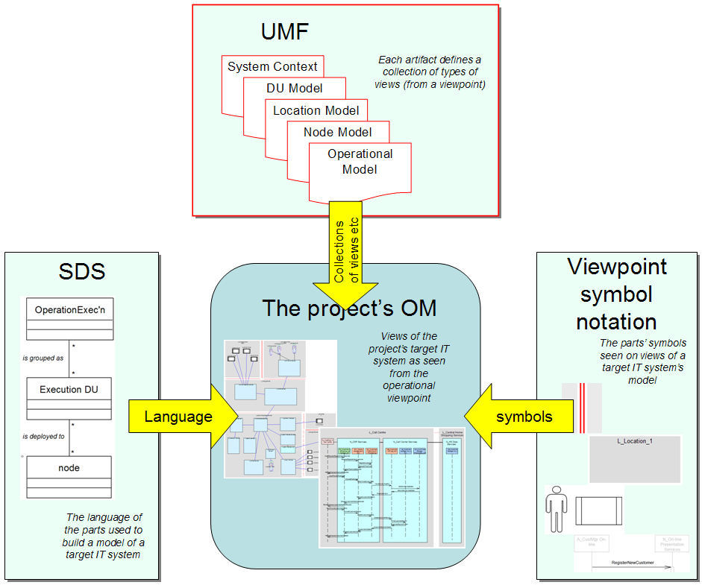
Figure 1: Relationship between IBM’s SDS, UMF and symbol notation

Figure 1 highlights how IBM’s formal approach to modelling supports the documentation of a target IT system’s model through:
- IBM’s System Description Standard, which provides formal definitions of the types of element the model can contain, together with the permitted relationships between these elements - such as what a Node is and how it is related to Deployment Units, Connections and the like.
- IBM’s Unified Method Framework, which provides a set of artifact definitions, each documenting how the target IT system’s model is to be presented from a particular viewpoint (such as the operational viewpoint), and as collated this document.
- A standard notation for all symbols (in [Ref 1]), providing a universal way of drawing the symbols that represent these model elements on any and all views of the target IT system’s model as defined by each UMF artifact.

Notation and “Perspectives”
The artefacts associated with the operational viewpoint document the target IT system’s model using a number of “perspectives”, each of which may require some variation in the notation used for the model’s elements’ symbols and their layout on the viewpoints’ views:

Logical View: In which the required logical characteristics and capabilities of the target IT system’s model’s elements and their relationships are presented: the view is a “specification view” of the target IT system’s model.
Physical View: In which the physical technologies needed to deliver these characteristics and capabilities are identified and configured, whether they are to be bought (software packages and hardware) or developed (software development and bespoke hardware): the view is an “implementation view” of the target IT system’s model.

Structure View: In which a view documents the static relationships between the model’s elements.
Walkthrough View: In which a view documents the way the model’s elements interact, in order to support the dynamic requirements placed on the target IT system.

Application View: Representing elements in the target IT system on which the architect is focused - the views “seen” from their viewpoint.
Technical View: Representing the elements of the target IT system’s model needed to make “the application” work – technical views include elements needed by the target IT system’s model to achieve “the application’s” characteristics.

Non-located View: In which the target IT system’s model’s elements (sometimes types of element) are modelled without regard for where they are.
Located View: In which representative instances of the target IT system’s model’s elements are placed in or across the locations over which the system will be deployed

Unless specifically distinguished in the following sections, the core notation for the target IT system’s model’s symbols in the operational aspect’s views are:
- Are neutral to the first three of these perspectives, although there may be additional options whenever required for clarity or layout
- Represent “located model elements” and are therefore all “located views”.
The inter-relationships between these four pairs of views are discussed in detail in [Ref 2] and [Ref 4 & 5].

Operational Viewpoint View Notations
The Operational Model artifact [is the central artifact that] describes the "operational aspect” of an IT system's architecture. It describes the required operational characteristics and capabilities of the IT system architecture and represents, at an architectural level, the network of computer systems and their associated peripherals, together with the systems software, middleware, and application software that they run in order to support the users of the system .
Operational Modelling helps the IT Architect understand where everything is and/or where everything should go, what it is doing or will do there, and what will be needed to help ensure the [distributed] IT system continues to operate effectively and efficiently. [Ref 4]
Diagrammatic views of the operational viewpoint are organised into a number of “secondary” viewpoints as defined by UMF’s operational artifacts:
- System Context (ART 0651)
- Freeform diagram
- Logical functional viewError: Reference source not found
- Hybrid functional viewError: Reference source not found
- Physical functional viewError: Reference source not found
- Logical operational view
- Physical operational view
- Deployment Unit Model (ART 0525)
- DU table
- DU matrix
- Location Model (ART 0523)
- Logical location structure view
- Physical location structure view
- Zone Model (ART 0511)
- Zone view
- Node Model (ART 0524)
- Logical node structure view
- Physical node structure view
- Operational Model (ART 0502)
- Logical operational view
- Physical operational view
- Logical walkthrough view
- Freeform logical walkthrough diagram
- Freeform physical walkthrough diagram
The detailed notation for each of these views and diagrams of the operational viewpoint is presented in the following sections.

Note 1: “views and diagrams”
Those listed above as
- “Views” such as the Operational Model’s “Logical walkthrough view”
are faithful representations of the underlying target IT system model – all symbols and their relationships represent model elements and their relationships as defined by SDS.
- “Diagrams” such as the Operational Model’s “Freeform logical walkthrough diagram”
also include symbols for model elements defined by SDS, but do not faithfully present their relationships – rather, they have an element of “sketching” and therefore some ambiguity of meaning.
Note 2: Connective symbols, relationships - and freeform lines
In general, care is needed to distinguish the meaning of “lines” on diagrammatic views – they may represent connective model elements, or a relationship between two model elements:
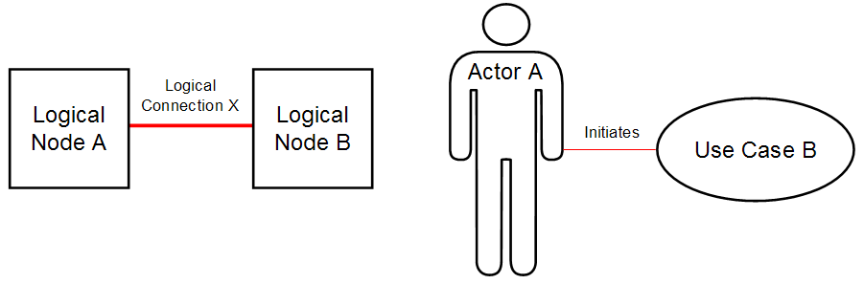
Figure 2: Connective model element symbol (left) and model element relationship (right)
Figure 2 highlights a connective model element (in this case, a logical connection between two nodes) on the left, and a model element relationship (showing an initiates relationship) on the right. The distinction may be clearer if – quite artificially, it is never drawn this way – the left hand view is redrawn with the model elements’ connects to relationships explicitly shown:
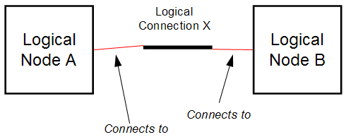
Figure 3: If the relationship between connective and nodal model elements was explicitly drawn
All lines in all of the operational viewpoint’s views are symbols of connective model elements (connections, borders, DU connectors and DU messages) – there are no “relationship lines” on any of them. The operational viewpoint’s diagrams do, however, include “freeform lines” that do not represent any part of the underlying model, but are used by the modeller for their own purposes and whose meaning must therefore be expressly defined via a key on or near the diagram.

System Context (ART 0651)
With the exception of the symbols on the Freeform System Context Diagram, these views use standard symbols and naming conventions for all model elements as defined in [Ref 1]. Other pictorial or schematic symbols may be used, typically requiring a key to clarify meaning.

Freeform System Context Diagram
The target IT system’s context may be documented in a freeform manner, as a set of inputs and outputs between the target IT system and its various human and IT system users:
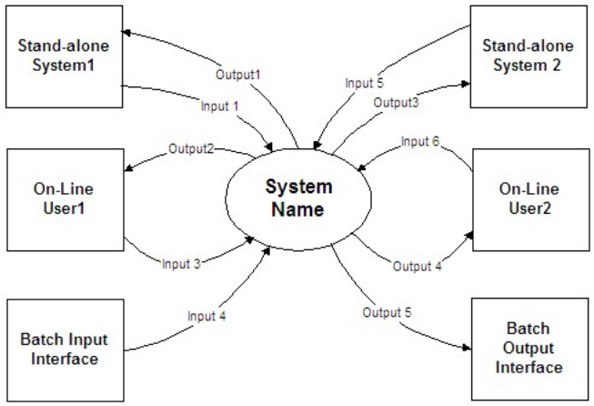
Figure 4: System Context freeform diagram
As a freeform diagram, the exact nature of the “external agents” may or may not be known, and if they are they must be defined – for example, it may not (yet) be clear if “On-line User1” represents a physical user (such as a customer or a Customer Services Representative), or a logical actor (such as customer and CSR both acting as a “home shopper”); or if the two batch interfaces are part of the same physical system – and whether this system is System 1, System 2, or some other system.
The nature of the inputs and outputs may also not be known, or if they are they must be defined via a key – for example, are they functionally describing what goes in and out of the target IT system, or the operational manner in which the input/output is transported, or the underlying connectivity mechanism?
If an explicit link is required between the “black box” viewpoint of the system context and the “white box” viewpoints of component and operational modeling, then it is likely more formal views will be required, in which some or all of the symbols represent specific types of parts of the target IT system that are also observable from these other viewpoints:

Logical Functional View
The System Context’s Logical Functional View includes symbols for
- The target IT system
- Actor
- Logical exchange
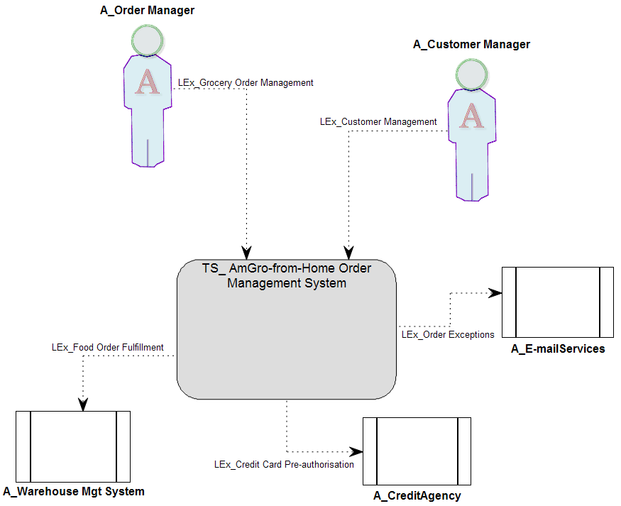
Figure 5: System Context Logical Functional View
Notation notes
- Figure 5 shows “core” notation for the target IT system and logical exchange symbols, but chooses to use “additional options” notation for the symbols of the system’s actors, in order to distinguish actors of human and IT system users.
- If a logical exchange’s symbol includes an arrow head, then this points from the initiator to the recipient of the exchange (e.g. actor “A_Order Manager” initiates logical exchange “LEx_Grocery Order Management”)
- In order to facilitate an understanding of the relationship between this functional viewpoint and the requirement viewpoint (specifically use case modelling), it may be helpful to model actors having different exchanges with the target IT system, each one representing the collection of use cases initiated by that actor, together with those the actor supports; if necessary refactoring the actor’s exchanges to ensure this one-to-many relationship between exchange and use case. If this is the case, each logical exchange will have one symbol on the view.
- In order to facilitate an understanding of the relationship between this functional viewpoint and its operational equivalent (see section “Logical Operational View”), it may be helpful to model each actor’s interaction with the target IT system as a single exchange; if necessary refactoring the users’ roles (modelled as actors) to ensure this one-to-one relationship between actor and exchange.

Physical Functional View
The System Context’s Physical Functional View includes symbols for
- The target IT system
- Actor
- Logical exchange
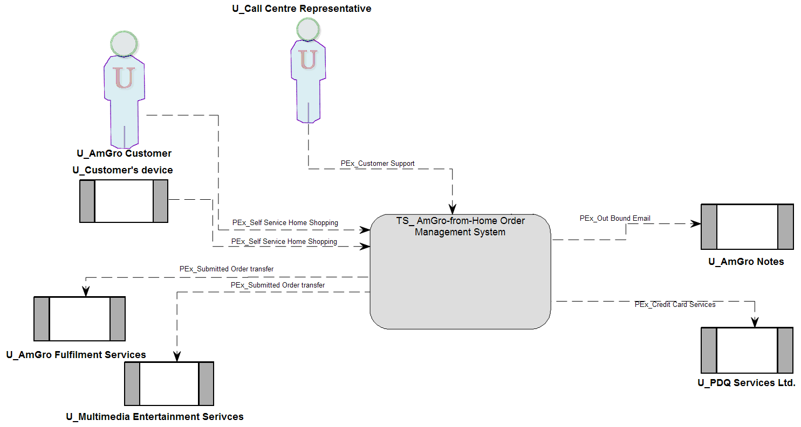
Figure 6: System Context Physical Functional View
Notation notes
- Figure 6 shows “core” notation for the target IT system and physical exchange symbols, but chooses to use “additional options” notation for the symbols of the system’s users, in order to distinguish human and IT system users.
- If a physical exchange’s symbol includes an arrow head, then it points from the exchange’s initiator to its recipient (e.g. user “U_AmGro Customer” initiates physical exchange “PEx_Self Service Home Shopping”)
- As a view including symbols for physical model elements, there are no constraints on the cardinality between users and physical exchanges. Therefore the view may include symbols showing multiple users engaged in the same physical exchange (i.e. multiple symbols for the same exchange), or each type of user may be engaged in multiple physical exchanges).

Logical Operational View
The System Context’s Logical Operational View includes symbols for
- The target IT system
- Actor
- Logical access mechanism
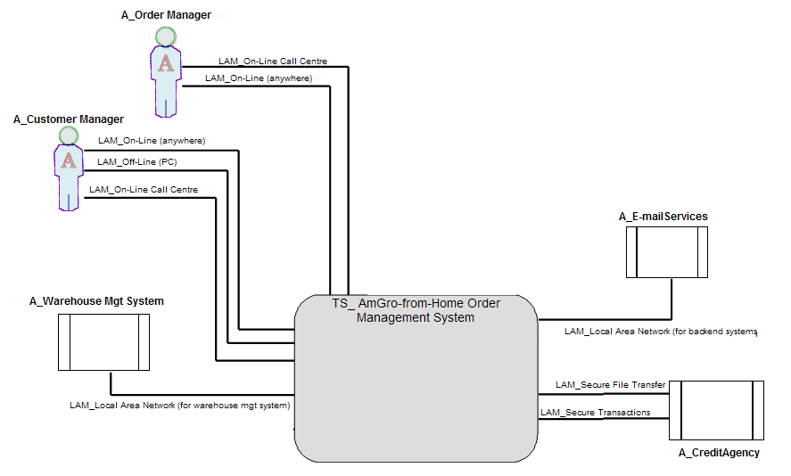
Figure 7: System Context Logical Operational View
Notation notes
- Figure 7 shows “core” notation for the target IT system and logical access mechanism symbols, but chooses to use “additional options” notation for the symbols of the system’s actors, in order to distinguish actors of human and IT system users.
- If a logical access mechanism’s symbol includes an arrow head, then it represents a one-way access mechanism, pointing from the source to the recipient (not exemplified here).
- In order to facilitate an understanding of the relationship between this operational viewpoint and its functional equivalent (see section “Logical Functional View”), the model may record multiple access mechanisms being used by an actor to accomplish their logical exchange with the target IT system. Therefore the view may include symbols showing multiple actors using the same logical access mechanism (i.e. multiple symbols for the same access mechanism), or each type of actor using multiple logical access mechanisms.

Physical Operational View
The System Context’s Physical Operational View includes symbols for
- The target IT system
- User
- Physical access mechanism
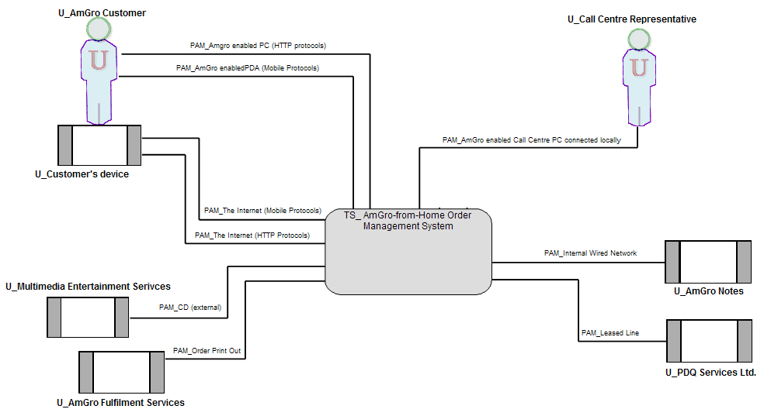
Figure 8: System Context Physical Operational View
Notation notes
- Figure 8 shows “core” notation for the target IT system and physical access mechanism symbols, but chooses to use “additional options” notation for the symbols of the system’s users, in order to distinguish human and IT system users.
- If a physical access mechanism’s symbol includes an arrow head, then it represents a one-way access mechanism, pointing from the source to the recipient (not exemplified here).
- As a view including symbols for physical model elements, there are no constraints on the cardinality between users and physical access mechanisms. Therefore the view may include symbols showing multiple users using the same physical access mechanism (i.e. multiple symbols for the same access mechanism), or each type of user using multiple physical access mechanisms.

Hybrid Views
It may be helpful to illustrate a variety of logical and physical, functional and operational (i.e. hybrid) combinations, such as
- The target IT system
- User
- Logical exchange
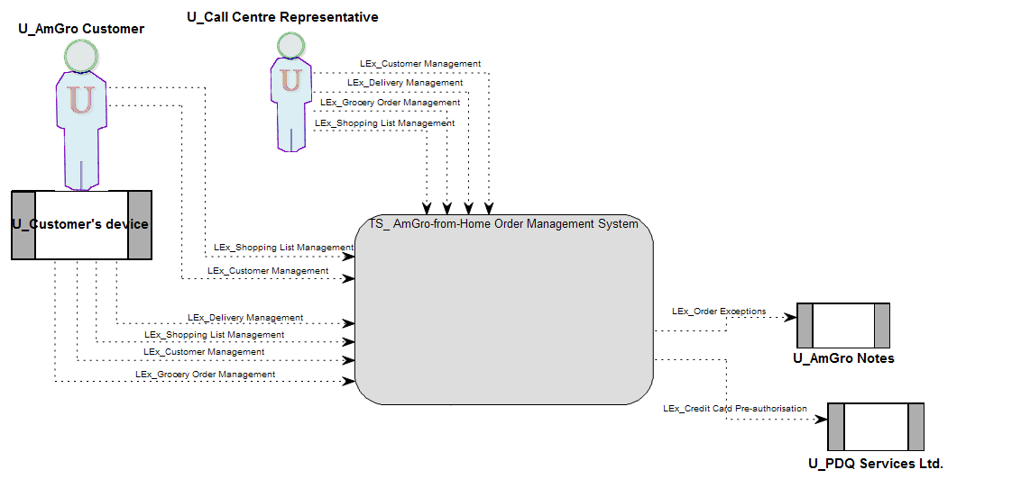
Figure 9: System Context Hybrid Functional View (example: users and logical exchanges)
Notation notes
- Figure 9 shows “core” notation for the target IT system and logical access mechanism symbols, but chooses to use “additional options” notation for the symbols of the system’s users, in order to distinguish human and IT system users.
- As a view including symbols for physical model elements, there are no constraints on the cardinality between users and logical exchanges. Therefore the view may include symbols showing multiple users using the same logical exchange (i.e. multiple symbols for the same exchange), or each type of user using multiple logical exchanges.

Deployment Unit Model (ART 0525)
The Deployment Unit model is represented using tables and textual descriptions. The DU naming conventions used within these tables and text must adhere to the standard prescribed by [Ref 1].

DU Descriptions
Each component’s DUs may be documented as a table (in which it may be easier to relate each component individually to the collection of DUs being used to represent it):
Component | Represented by Presentation DU | Represented by Execution DU | Represented by  Data DU | Represented by Installation DU
C_Dialog Control | P1_Order & Delivery  P2_Customer & SL  P3_Complaints | E11_Dialog Mgt | - | I1_Dialog Control
C_Order Processing | - | E1_Customer, Order & SL Processing | D1_Customer, Order & Shopping List Profiles | I2_AfH FE Application
C_Credit Authorisation Mgr | P8.1_Credit Agency (authorization)  P8.2_ Credit Agency (hotcard list) | E5_Credit Authorization | D5.1_Credit Authorization (hot cards)  D5.2_Accepted Card Types | I6_Credit Authorization Mgr
Table 1: Component’s DUs
Or alternatively via a matrix (in which it may be easier to see the grouping and splitting of each aspect of all Components across each DU type):
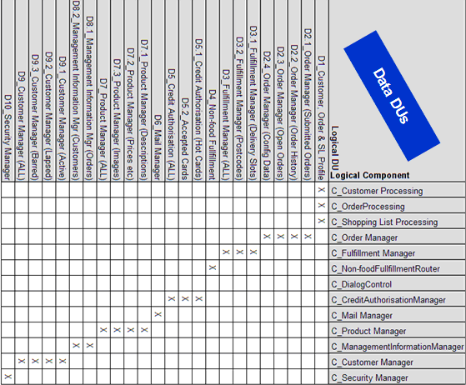
Table 2: Component’s Data DUs

A summary of each DU’s characteristics may be presented in tabular form (in this case, for the Data DUs listed in Table 1):
 | Data DU | Type | Unit Size (bytes) | Number (after 2 yrs) | Currency | Volatility | Comments
D1 | User Usage Profile | Structured, "flat file"? | 1kB / user | 50,000 | real-time | low
D5.1 | Hot Cards list | Structured | -- | 1MB | High | Medium (nightly)
D5.2 | List of accepted payment cards | Structured | 1kB per card type | 20 | High | Low | estimate
Table 3: Data DU Characteristics

Location Model (ART 0523)
These views use standard symbols and naming conventions for all model elements as defined in [Ref 1]. Other pictorial or schematic symbols may be used, typically requiring a key to clarify meaning.

Location Structure Views
The Logical and Physical Location Structure Views portray the “landscape” over which the target IT system and its human and IT system actors (logical view) or users (physical view) are deployed, as logical or physical locations and the available connectivity between them (modeled as logical and physical borders).
Both logical and physical views of the location model use the same symbols for
- Logical or Physical Location
- Logical or Physical Border
This section uses logical views to illustrate the location model’s notation.
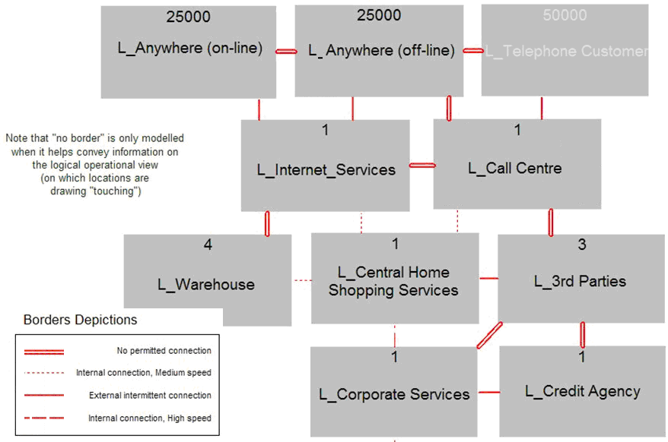
Figure 10: Location Model Structure View (borders drawn point-to-point)
Notation notes
- Figure 10 shows “core” notation for logical location and logical border symbols.
- It may be necessary to explicitly include symbols for borders across which there is “no permitted connection” in this particular model – not including a symbol may suggest there is “no border” at all.
The location model may exhibit complex connectivity between locations which, if drawn as a “box and line” diagram such as Figure 10, will exhibit borders’ symbols “crossing”. Also, when used as the backdrop to the Operational Model’s views, using this point-to-point border notation may make it difficult to distinguish borders from located connections drawn in a similar fashion between located nodes. In these cases, a specialized border notation should be used that facilitates a distinction between available connectivity (modeled as borders) and required connectivity (modeled as connections):
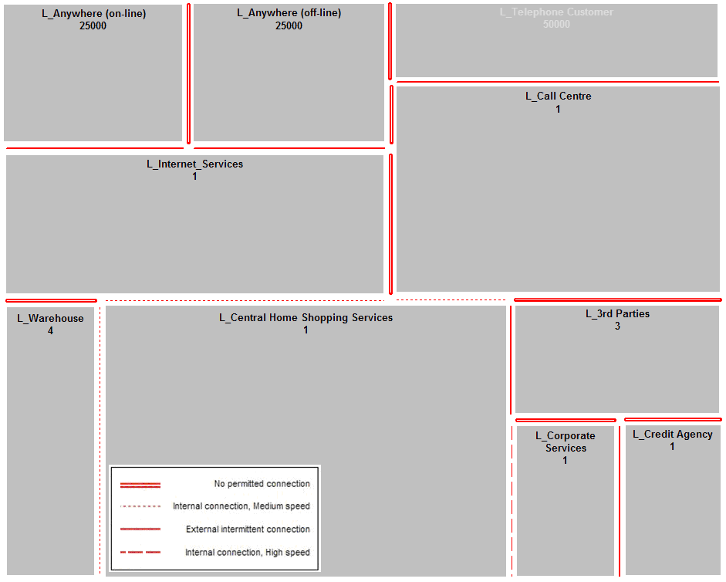
Figure 11: Location Model Structure View (borders drawn parallel to locations))
Notation notes
- Figure 11 shows “core” notation for logical location and logical border symbols.
- This alternate notation may preclude showing symbols for all involved borders (i.e. those that “cross” in Figure 10, such as may exist between logical locations “L_3rd Parties” and “L_Warehouse”), and it will therefore sometimes be necessary to lay the view out carefully so that all “involved” borders can be drawn.
- To ensure the view explicitly shows that two locations have no permitted connectivity for this target IT system, a symbol for a “no permitted connection” border is often drawn.

Zone Model (ART 0511)
These views use standard symbols and naming conventions for all model elements as defined in [Ref 1]. Other pictorial or schematic symbols may be used, typically requiring a key to clarify meaning.

Zone View
Zones are a semi-geographic concept, in which the things inside the zone all share the same value for a specific characteristic, with boundaries between zones, delineating a change in the specific characteristic.
All views portraying zones use the same notation for the model elements’ symbols for:
- Zone
- Boundary
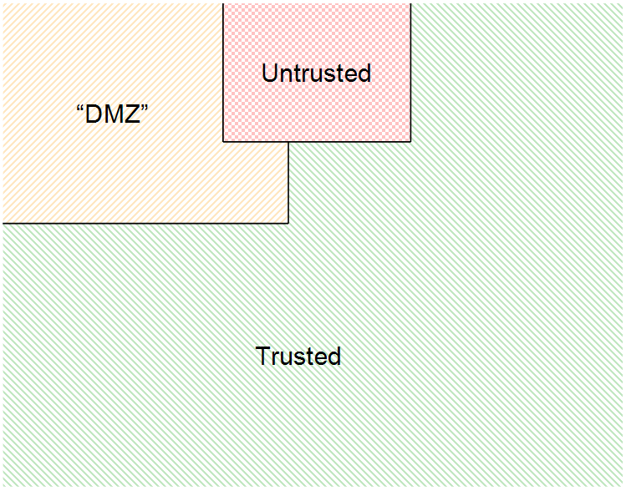
Figure 12: Zone View, showing different security zones and their boundaries
Figure 12 illustrates “security” zones, although sones may distinguish any characteristic, such as “level of available systems management”, “environmental conditions”, or “inside v outside the target IT system”. In all cases, a boundary represents a change in the characteristic’s value.
Notation notes
- Figure 12 shows “core” notation for zone and boundary symbols.
- The visual arrangement of zones may choose to accentuate zoning, such as drawing “zone layers” left-to-right or top-to-bottom; or, as in this case, may be arranged as a zoning overlay on a model view laid out in a manner that highlights other concerns, such as is seen in Figure 13.
Being such an abstract concept, it may be argued that views showing only zones and their boundaries are less useful than those that super-impose zones onto other views, such as for the Node Model’s Logical Node Structure View:
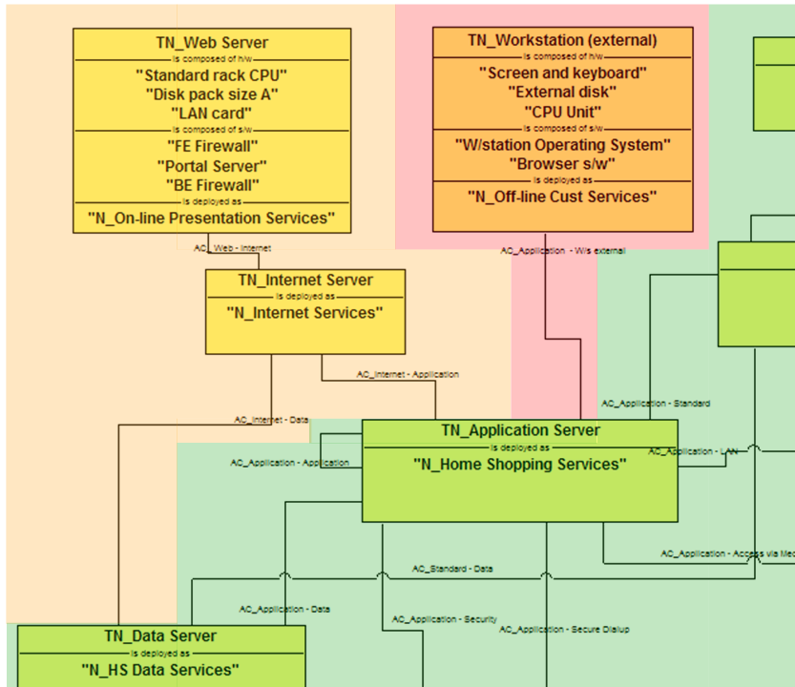
Figure 13: Zone View overlay on another view, such as a Node Model’s Node Structure View
Notation notes
- As is the case in Figure 13, it is normal practice for zoned logical views to unambiguously documenting each model element as being in “exactly one” zone – well defined logical model elements’ have “single valued” service level characteristics.
- As Figure 13 shows, however, such views may be difficult to draw, particularly for symbols of “connective” model elements - as is the case in Figure 14 in which several logical connections appear to span zones:
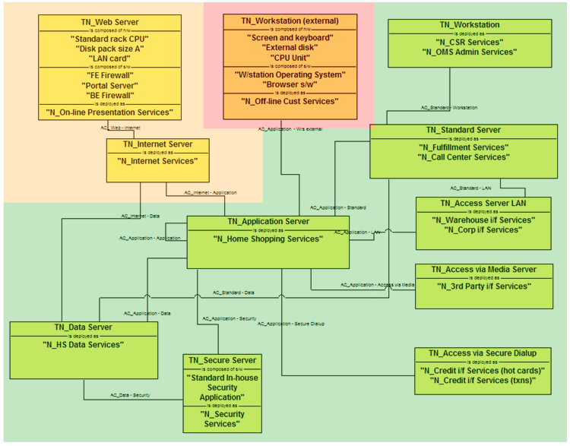
Figure 14: Zone View overlay showing inaccurate zone boundaries
- It is common for physical model elements to span zones (i.e. they can have multi-valued service level characteristics), and therefore zoned views in which model elements’ symbols span zones are commonplace.

Node Model (ART 0524)
These views use standard symbols and naming conventions for all model elements as defined in [Ref 1]. Other pictorial or schematic symbols may be used, typically requiring a key to clarify meaning.

Logical Node Structure View
The Logical Node Structure View portrays a structure of logical nodes and their logical point-to-point connections. These views underpin an understanding of what the nodes do, what they are made up of (usually as collections of software and hardware), and how they work together.
The logical view of the node model includes symbols for
- Logical Node
- Logical Connection
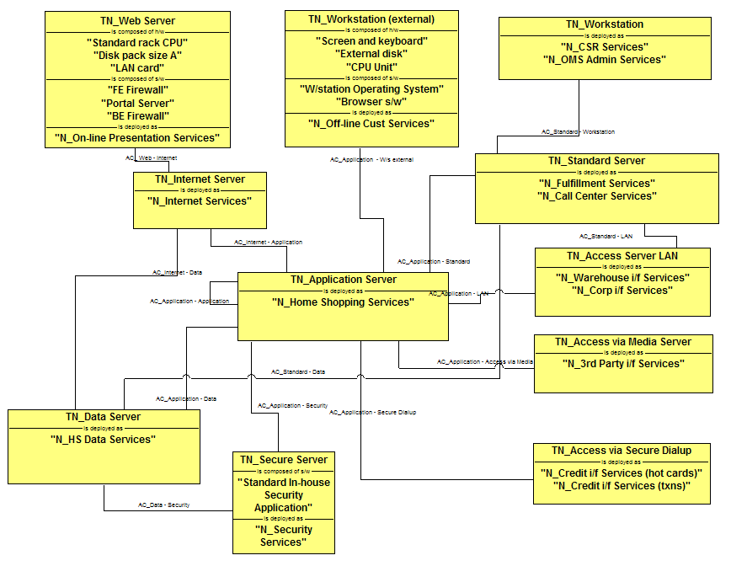
Figure 15: Logical Node Structure View showing point-to-point logical connections
Notation notes
- Figure 15 shows “core” notation for logical node and logical connection symbols.
- Logically, computers are connected together “point to point”, and therefore symbols for logical connections are drawn directly connected between logical node symbols.
- Normally, logical structure views of the node model do not include any placement information – i.e. the nodes are not placed; although it may be appropriate to overlay zones distinguishing a certain characteristic such as security level or environmental conditions (zones are not shown on Figure 15, but are exemplified on a logical node view in UMF Artifact Zone Model (ART 0511)).
- The absence of placement information, and the consequential generic nature of the logical node definitions means these views are often used to portray “standard” nodes and can therefore be thought of as representing node types.
- As seen in several nodes on Figure 15, it may be appropriate to document the node’s composition as a collection of hardware and software. Alternatively, when working on more precise models, these views may also (or instead) list the nodes’ composition as collections of Deployment Units.
- A logical node structure view may
- Involve application level nodes, in which each node supports one specific aspect of the business application;
- Portray technical level platforms, supporting specific technical functionality (as is the case in Figure 15)
- A mix of both application and technical levels.
- Each node type may form the basis of one or more of the target IT system’s deployed located node instances, as documented in the Operational Model’s Operational Views. Similarly, the same may be the case for each connection.

Physical Node Structure View
The Physical Node Structure View portrays a structure of physical nodes and their physical networked connections. These views underpin an understanding of what the nodes do, what they are made up of (usually as collections of software and hardware), and how they work together:
The physical view of the node model includes symbols for
- Physical Node
- Physical Network
- Physical Connection
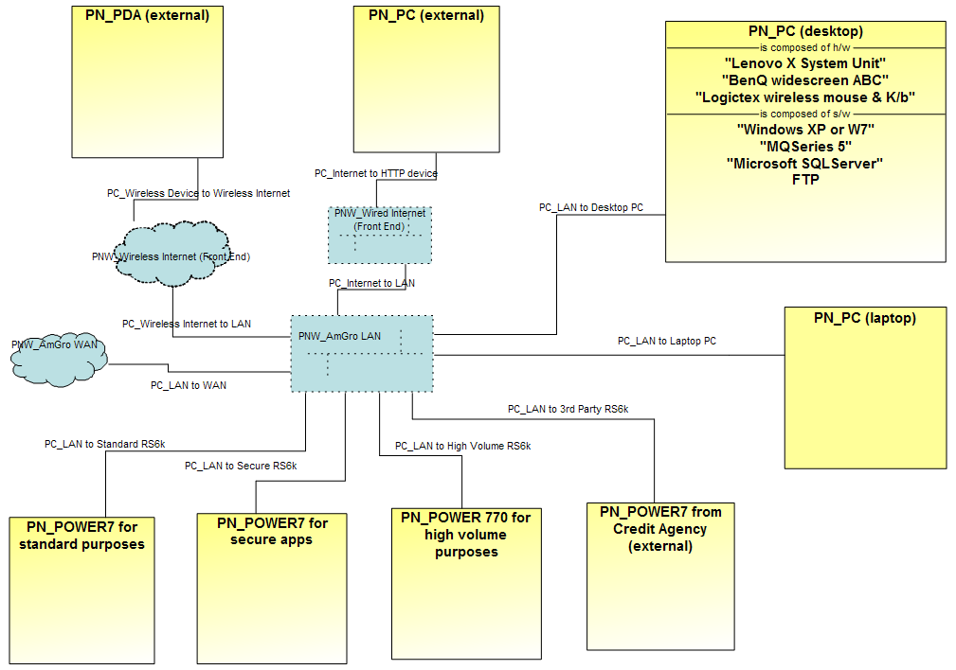
Figure 16: Physical Node Structure View showing networked physical connections
Notation notes
- Figure 16 shows “core” notation for physical node and physical connection symbols, but chooses to use “additional options” notation for the physical network symbols, in order to distinguish different types of physical network.
- Physically, computers may be connected together on a network and, therefore, symbols for physical connections connect between symbols for physical nodes and either physical network symbols (multi-point) or other physical node symbols (direct connection, not shown on Figure 16).
- This notation is not intended to imply a specific physical topology; rather it is a simple approach to drawing “any-to-any” physical connections. Alternative physical connection notations are presented in [Ref 1].
- Normally, physical structure views of the node model do not include any placement information – i.e. the nodes are not placed; although it may be appropriate to overlay zones distinguishing a certain characteristic such as security level or environmental conditions (zones are not shown on Figure 16, but are exemplified on a logical node view in UMF Artifact Zone Model (ART 0511)).
- The absence of placement information, and the consequencial generic nature of the physical node definitions means these views are often used to portray “standard” nodes and can therefore be thought of as representing node types.
- As seen in several nodes on Figure 16, it may be appropriate to document the node’s composition as a collection of hardware and software. Alternatively, when working on more precise models, these views may also (or instead) list the nodes’ composition as collections of Deployment Units.
- A physical node structure view may
- Involve application level nodes, in which each node supports one specific aspect of the business application;
- Portray technical level platforms, supporting specific technical functionality (as is the case in Figure 15)
- A mix of both application and technical levels.
- Each node type may form the basis of one or more of the target IT system’s deployed located node instances, as documented in the Operational Model’s Operational Views. Similarly, the same may be the case for each connection.

Operational Model (ART 0502)
These views use standard symbols and naming conventions for all model elements as defined in [Ref 1]. Other pictorial or schematic symbols may be used, typically requiring a key to clarify meaning.

Logical Operational View
The Logical Operational View portrays the structure of the target IT system’s logical parts as they are deployed across logical locations and borders. It brings together parts portrayed in other views of the operational viewpoint showing how
- The solution’s human and IT System actors are located, deployed across logical locations.
- The solution’s logical located Deployment Units work together (via logical located DU connectors) in support of the target IT system’s located human and IT system actors
- These logical located DUs and their connectors are supported on logical located nodes and across logical located (point-to-point) connections and logical access mechanisms
- The solution’s logical located nodes are deployed across logical locations, with their (required) inter-node logical connections and node-actor logical access mechanisms supported by the (available) inter-location connectivity (modeled as borders).
The logical operational view of the operational model includes symbols for
- Logical Location
- Logical Located Actor within one Logical Location
- Logical Located Node within one Logical Location
- Logical Located DU within one Logical Located Node
And
- Logical Border between Logical Locations
- Logical Access Mechanism between Located Actor and Logical Located Node
- Logical Located Connection between Logical Located Nodes
- Logical Located DU Connector between Logical Located DUs and Located Actors
or between Logical Located DUs
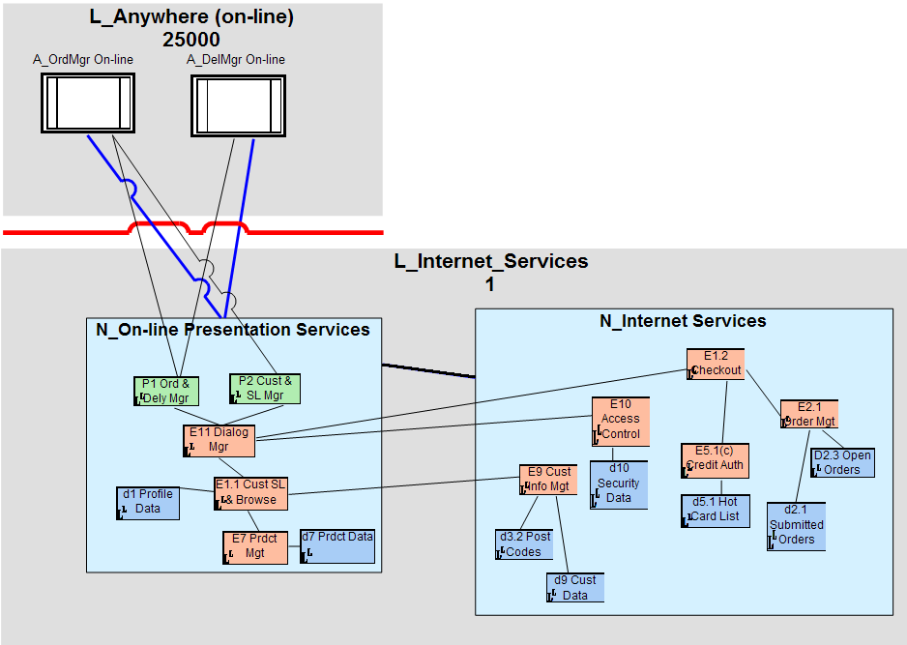
Figure 17: Logical Operational View (Complete, showing logical located DUs and connectors)
Notation notes
- Figure 17 shows “core” notation for all symbols appearing on logical operational views, except for located actor whose symbols exploit an “additional options” notation to distinguish human and IT system located actors. (Note that colour is partly from the “additional options” notation and partly for visual clarity).
- It is not necessary to portray all types of model elements on this view. For example, it may not be appropriate (or possible) to include symbols for logical located DUs and their located connectors, in which case the view is referred to as a Outline Logical Operational View (the equivalent physical operational view is shown in Figure 20).
- Logical border symbols have been drawn parallel to the symbols for the associated logical locations, helping differenciate symbols for logical access mechanisms, logical located connections and logical located DU connectors which are all drawn “point to point”.
- Logical access mechanisms may support one or more located actors (so long as they are in the same logical location). Therefore the view may include multiple symbols for the same logical access mechanism. Additionally, a logical access mechanism is supported by one logical located node, and one located actor may use one logical access mechanism.
- Drawing logical located DU symbols drawn inside logical located nodes is one of several described in [Ref 1].
- Logical Located Connections and Logical Access Mechanisms support the transport of one or more Logical Located DU Connectors.
- [Ref 1] defines a number of alternative notations for nodes’ symbols, including the listing of attributes of various model elements within or near the symbol, which may be more appropriate on a outline view:
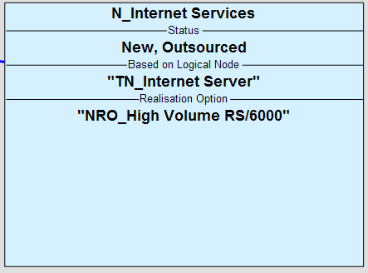
Figure 18: Displaying model element attributes
And a full listing of the logical located node’s software and hardware components, which may be of most use when configuring individual nodes:
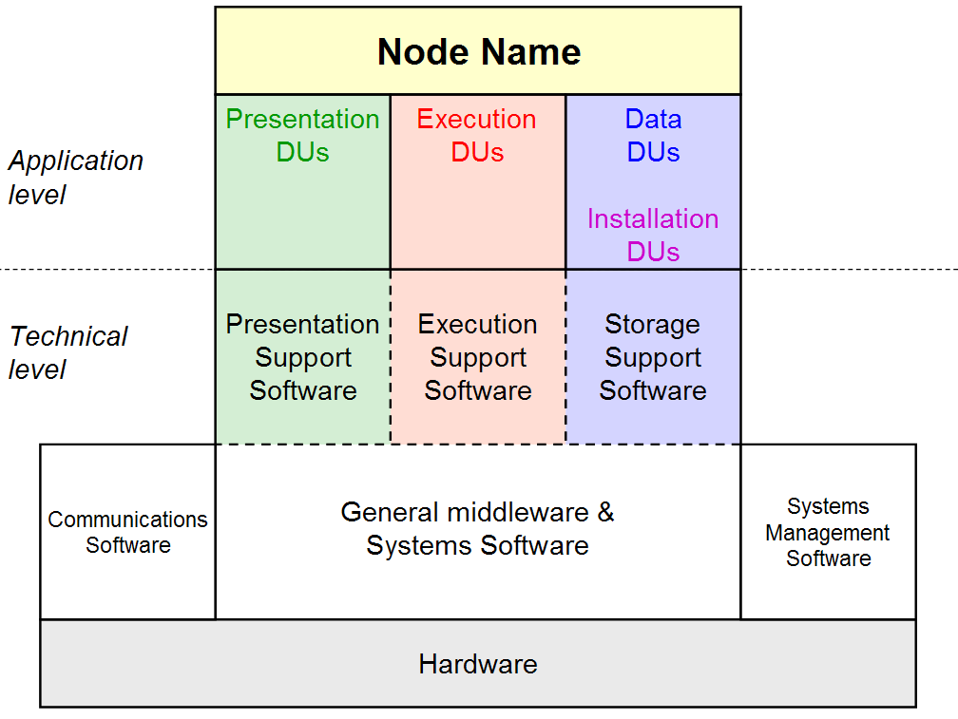
Figure 19: Node box diagram

Physical Operational View
The Physical Operational View portrays the structure of the target IT system’s physical parts as they are deployed across physical locations and borders. It brings together parts portrayed in other views of the operational viewpoint showing how
- The solution’s human and IT system users are located, deployed across physical locations.
- The solution’s physical located Deployment Units work together (via physical located DU connectors) in support of the target IT system’s located human and IT system users
- These physical located DUs and their connectors are supported on physical located nodes and across physical located (network) connections and physical access mechanisms
- The solution’s physical located nodes are deployed across physical locations, with their (required) inter-node physical network connections and node-user physical access mechanisms supported by the (available) inter-location connectivity (modeled as borders).
The physical operational view of the operational model includes symbols for
- Physical Location
- Located User within one Physical Location
- Physical Located Node within one Physical Location
- Physical Located Network within one Physical Location
And
- Physical Border between Physical Locations
- Physical Access Mechanism between Located User and Physical Located Node
- Physical Located Connection between Physical Located Nodes and Physical Located Network
or between Physical Located Nodes
- Physical Located DU Connector between Physical Located DUs and Located Users
or between Physical Located DUs
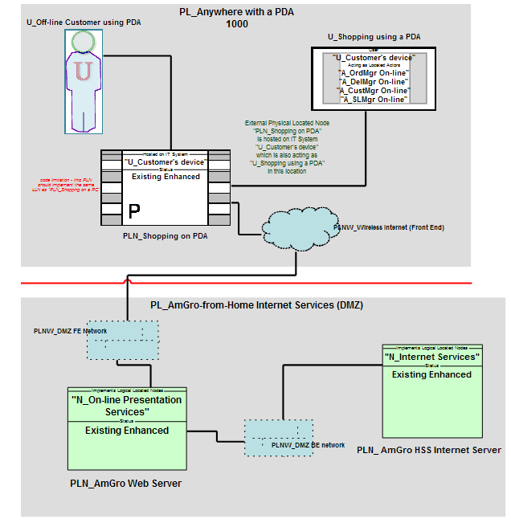
Figure 20: Physical Operational View (Outline, no physical located DUs or connectors)
Notation notes
- Figure 20 shows “core” notation for all symbols appearing on physical operational views, except for located actor, physical located network and physical located external node whose symbols exploit “additional options” notations to distinguish sub-types. (Note that color is for visual clarity).
- It is not necessary to portray all possible types of model element on this view. For example, as is the case in Figure 20, may not be appropriate (or possible) to show physical located DUs and their located connectors, in which case the view is referred to as a Outline Physical Operational View. Physical located DUs and their point-to-point connectors may be drawn in a similar fashion to that presented and discussed for the Logical Operational View.
- Physical border symbols have been drawn parallel to the associated physical locations, helping differentiate symbols for physical access mechanisms, physical located connections and physical located DU connectors which are drawn “point-to-point”.
- Physical access mechanisms may support one or more located users (so long as they are in the same physical location), and are provided by one physical located node. Therefore the view may include multiple symbols for the same physical access mechanism.
- Additionally, located users may use one or more physical access mechanisms, and physical located nodes may support one or more physical access mechanism.
- Physically, many computers may be connected together on one network and, therefore, symbols for physical located connections connect between symbols for physical located nodes and either physical located network symbols (multi-point) or other physical located node symbols (not shown on Figure 20). This notation is not intended to imply a specific physical topology, rather it is a simple approach to drawing “any-to-any” physical located connections. Alternative Physical Located Connection notations are presented in [Ref 1].
- As an outline view, Figure 20 does not portray physical located DUs. In a complete view, physical located DUs and their physical located DU connectors may be portrayed as shown for the logical operational View in Figure 17. However, since physical located DU connectors are “point to point” (between pairs of physical located DUs), they must “route” end-to-end across the physical connection network: For example:
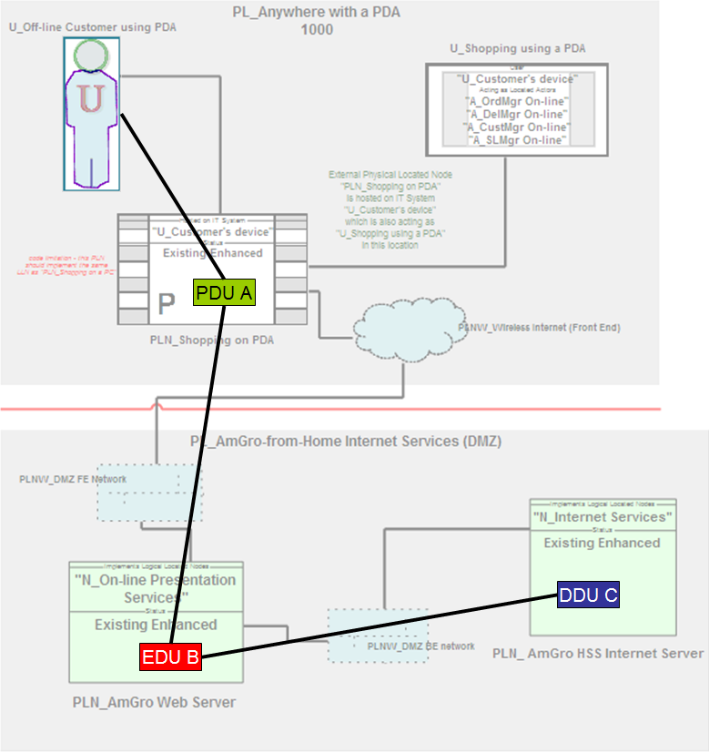
Figure 21: Physical Operational View (Highlighting physical located DUs and connectors)
The symbol notation for physical located DUs drawn inside physical located nodes is one of several described in [Ref 1].

Logical Walkthrough View
The Logical Walkthrough View portrays the behaviour of the target IT system’s logical parts as they are deployed across logical locations and borders. It focuses on modeling the messages that flow between logical located DUs, portrayed against a backdrop of logical located nodes (hosting the DUs) and their logical located connections (the connectivity required to convey the messages’ inter-DU connectors. In addition, the view may include the logical locations and their available connectivity (as logical borders) over which the solution is deployed:
The logical walkthrough view of the operational model includes symbols for
- Logical Location
- Located Actor within one Logical Location
- Logical Located Node within one Logical Location
- Logical Located DU within one Logical Located Node
And
- Logical Border between Logical Locations
- Logical Access Mechanism between Located Actor and Logical Located Node
- Logical Located Connection between Logical Located Nodes
- Logical DU Message between Logical Located DUs or Located Actors
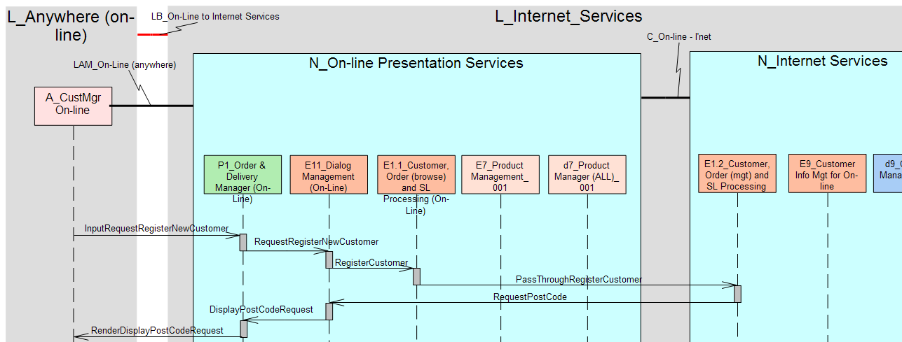
Figure 22: Logical Walkthrough View
Notation notes
- Figure 22 shows “core” notation for all symbols appearing on logical operational views. (Note that colour is partly from the “additional options” notation and partly for visual clarity).
- This view presents an accurate portrayal of the underlying target IT system model, since the located DUs are directly related to the functional viewpoint’s components, and correspondingly its inter-DU messages relate directly to the functional viewpoints messages. There will, however be occasions when this accuracy is too detailed or complex:

Freeform Walkthrough Diagram (logical and physical)
Walkthrough Views may be too detailed or complex. In which case, a less accurate freeform walkthrough diagram may be appropriate, in which freeform messages flow between nodes.
The freeform logical walkthrough diagrams of the operational model includes symbols for
- Logical Location
- Located Actor within one Logical Location
- Logical Located Node within one Logical Location
- Physical Border between Physical Locations
- Logical Freeform Message between Logical Located Node and Located Actor
or between Logical Located Nodes
The freeform physical walkthrough diagrams of the operational model includes symbols for
- Physical Location
- Located User within one Physical Location
- Physical Located Node within one Physical Location
- Physical Located Network within one Physical Location
- Physical Freeform Message between Physical Located Node and Located User
or between Physical Located Nodes
This section uses logical views to illustrate the freeform walkthrough diagram’s notation
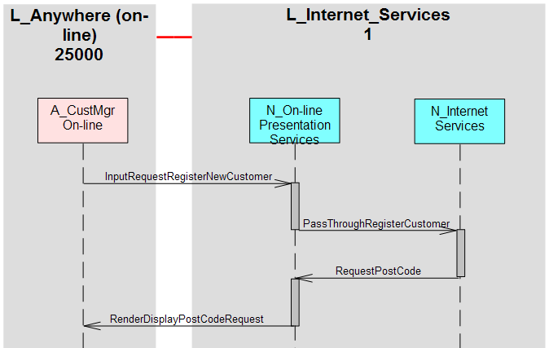
Figure 23: Freeform Walkthrough Diagram (“sequence style”)
Notation notes
- Figure 23 shows “core” notation for all symbols appearing on logical operational views. (Note that colour is partly from the “additional options” notation and partly for visual clarity).
- This notation follows the same “sequence view” style as the more accurate Logical Walkthough View. However, it may be appropriate to adopt the “collaboration view” style of Figure 24:
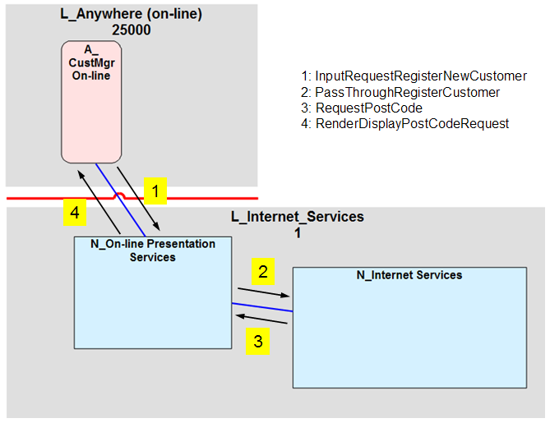
Figure 24: Freeform Walkthrough Diagram (“collaboration style”)
- Since a node is only a “grouping of DUs (and software/hardware)”, it cannot, in and of itself, send or receive messages. Therefore these inter-node messages are “freeform” and have only a loose and ill-defined relationship to the underlying inter-located DU messages.
- This notation may be used for logical and physical freeform walkthrough diagrams, although for physical diagrams the messages may “route” across several physical located connections connecting any number of physical located nodes and physical located networks.

References
Some of these are referred to in the body of the document; others provide examples and further reading:

- “SDS R3: Symbols Notation for the Operational Viewpoint”; Ian Charters (2012)
To be referenced by Tom Seevers
- “System Description Standard R3: Semantic Specification”; Philippe Spaas (2008)
https://w3.tap.ibm.com/w3ki/display/SDSR3/SDS+R3+Semantic+Specification
- “An Introduction to the IBM Views and Viewpoints Framework for IT Systems”; Denise Cook, Peter Cripps, Philippe Spaas (2008)
http://www.ibm.com/developerworks/rational/library/08/0108_cooks-cripps-spaas/
- “Team Solution Design White Paper: ‘Operational Modelling’”; Ian Charters (2012)
To be referenced by Tom Seevers
- “Team Solution Design White Paper: ‘System Context Modelling”; Ian Charters (2009)
http://gcd.ibm.com/RMCPlugins/TeamSolutionDesign/index.htm#core.tech.common.extend-ibm_int/guidances/whitepapers/system_context_modeling_8F09CE95.html
- “Architectural Thinking Class, AmGro-from-Home Case Study”; Ian Charters (2012)
- This is available to alumni of the class. An awareness level case-study, much of the material is presented by the “Architectural Thinking” course’s instructors.
- “TLU College 2, AmGro-from-Home Case Study”; Ian Charters (2011)
- This is available to alumni of the class. A technique level case study, much of the work is done by students.
- “AmGro-from-Home OMS sample encyclopaedia for SA4TeamSD”; Ian Charters (2012)
- Available to users of the SA4TeamSD configuration of Rational System Architect. For access, contact your Business Unit’s Deployment Contact, via
http://w3-03.ibm.com/support/tsdesign/tooling.html

Version Information

Revision Number | Revision Date | Summary of Changes | Author
V3.0 | July 2012 | Thorough revision to encompass evolution of SDS R3 (from ADS R2). Contemporary with “SDSR3: Symbols Notation for the Operational Viewpoint” | Ian Charters
V2.0 | March 2002 | Called “ADS Operational Model Notation V2” | Ian Charters

In this document pictorial representations are called views if they present a faithful rendering of the underlying model – i.e. all symbols represent methodologically defined elements or relationships. If, however, a representation is more sketch-like, in which the meaning of one or more symbols is not formally defined, then it is referred to as a diagram.
Such as a set of cross-indexed spreadsheets, a database or set of hierarchically organized files – whether as part of a Computer Aided Design Tool or as part of a manually managed modelling environment.
In this regard, the elements that appear on the operational viewpoint’s views are found in the SDS “IT System Operational ” package.
From the UMF “Operational Model (ART 0502)” Artefact. As at April 2012, the language used in this artefact description predates that used in this document, as well as many of the references cited. For example, the “operational aspect” is now refered to as the “operational viewpoint”.
All of the System Context’s views, both functional and operational, are included for completeness
In SDS, these would be messages, connectors, and access mechanisms – think “passenger journey”, “vehicle” and “road”.
DMZ = “Demilitarized Zone”, an common phrase describing an environment which is neither untrusted nor fully trusted,
Having connectivity available does not mean the deployed target IT system requires this connectivity.
Having connectivity available does not mean the deployed target IT system requires this connectivity.

